
KITH & KIN INTERNATIONAL COLLEGE
7/11 Kaoli Olusanya Street, Owode Ibeshe, Ikorodu, Lagos State.
THIRD TERM EXAMINATION 2024/2025 ACADEMIC SESSION

NAME
SUBJECT | BASIC SCIENCE | CLASS |  | JSS 1 | DURATION |  | 2 HOURS

SECTION A
OBJECTIVE [50 MARKS]

INSTRUCTION: ANSWER ALL QUESTIONS IN THIS SECTION
- The diagram shows the male reproductive and urinary systems .
Which structure produces the fluid part of semen ?
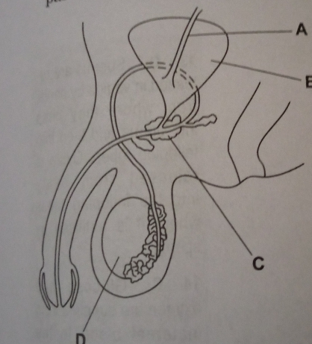

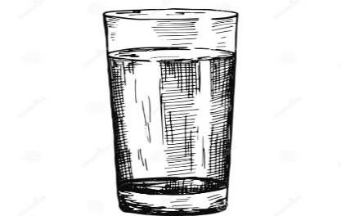
What is the compound name for the diagram above?
A. Fe₂SO₄

B. H₂O

C. H₂SO₄

D.Na₂SO₄

- The diagram shows a foetus in the uterus .
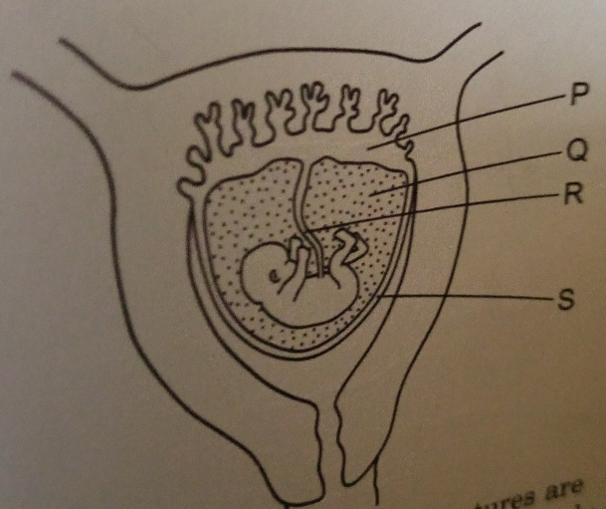
Which of the labelled structures are essential for feeding the foetus and which for supporting it and protecting it from mechanical shocks ?

 | Feeding | Supporting and protecting
A | P and Q | R and S
B | P and R | Q and S
C | Q and S | P and R
D | R and S | P and Q

- The diagram shows the female reproductive system.
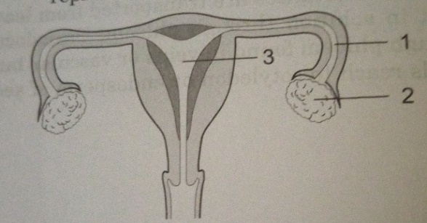
In which parts are the eggs and the zygote formed ?

 | Egg | Zygote
A | 1 | 2
B | 1 | 3
C | 2 | 1
D | 2 | 3

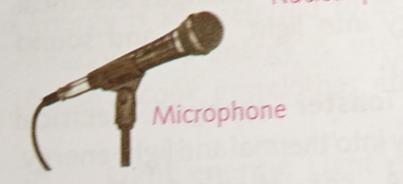
The type of energy transformation in the diagram above is
- Electrical to mechanical energy
- Electrical to sound energy
- Electrical to light energy
- Electrical to wind energy

- What is force ? A force is a thing that
- Changes the shape of a body
- Makes a body at rest move
- Changes the speed of a moving body
- All of the above

- One of the following is not a type of force
- Reversible
- Magnetic
- Gravitation
- Electrical

- When you push down on a spring mattress , the spring mattress reduces in size . As soon as you let go the force you applied , the spring mattress bounces back to its normal size . This shows that :
- Forces occur in pairs
- Air is pushing the mattress
- A force is not involved
- Contact force is acting

- Which of the following is NOT an example of a force?
- Tension
- Pull
- Motion
- Push

- The driver of a fast moving lorry suddenly applies brake and the lorry stops , what type of force is involved ?
- Magnetic force
- Electrical force
- Frictional force
- Gravitational force

- Gravitational force is a force of ______
- Opposition
- Separation
- Friction
- Attraction

- The earth has a large gravitational pull on object because the earth
- Is large in size
- Acts as magnet
- Revolves
- Rotates

- The earth gravitational pull on an object is represented by that objects
- Volume
- Size
- Weight
- Height above the ground

- When a metal ball of 20kg and a wooden ball of 10kg are dropped from the same height
- Both balls will reach the ground at the same time
- The metal ball will reach the ground before the wooden ball
- The wooden ball will fall side ways
- The metal ball will fall side ways

- In outer space , there is no earth gravitational pull and a person’s experience _____ there
- The mass of the object
- The mass of the earth
- The distance between the center of the object and the earth
- Weightlessness

- _____ is a large body of rock or gas that orbits the sun.
- Moon
- Planet
- Pluto
- Jupiter

- The planet , the sun and other smaller objects make up the ____
- Planet
- Neptune
- Solar system
- Uranus

- The inner planets are :
- Jupiter , Mercury ,Venus >Mars
- Mercury , Neptune , Mars , Earth
- Mercury , Venus , Earth , Mars
- Venus , Uranus , Mars , Venus

- Which of the planet as a lot of oxygen in its atmosphere?
- Jupiter
- Sun
- Mars
- Earth

- Which of the planets have orbits smaller than the asteroids belt and hence refers to as the ___
- earth ‘s moon planet
- gas inner planets
- outer planet
- middle planet

21. Gravitational force is a force of ?
- Attraction
- Friction
- ?Repulsion
- Separation

22. Space travel is done in which of the following?
- Space jacket
- Helicopter
- Passenger planes
- Spaceships

23. Which of these is a satellite?
- Atmosphere
- Sea
- Moon
- Sun

24. Satellites can be used for
- fireworks
- motorcars
- communication
- lighting

25. __________________ is a body that orbits a planet?
- Sun
- Dwarf
- Satellite
- Earth

26. Which of the following is not true of energy?
- Energy is the ability to do work
- Energy cannot be changed from one form to another
- Energy cannot be created
- Energy cannot be destroyed

27. Which of the following is an artificial satellite?
- Mercury
- Jupiter
- Reconnaissance satellite
- Moon

28. Which of the following is not a type of artificial satellite?
- Communication satellite
- Weather satellite
- Observation satellite
- Moon

29. Which of the following is called satellite of the earth?
- Asteroid
- Moon
- Comet
- Sun

30. The function of vitamin C in the body is to
- assist in blood clotting
- build the body
- help in healing wound
- help in respiration

31. Which of the following energies is contained in foods ?
- Chemical
- Heat
- Light
- Mechanical

32 . When drugs are taken without the doctor’s advice is called , it is called drug
- abuse
- addiction
- medication
- meddling

33. The scientist who studies weather is called
- weather forecaster
- scientist
- meteorologist
- astronomist

34. The S.I. unit of force is
- joules
- newton
- metre
- kilowatt

35. Which of these is NOT a source of energy?
- Coal
- Smoke
- Petroleum
- Natural gas

36. Forms of energy include the following except
- nuclear
- sound
- wind
- chemical

37. Calculate the potential energy (P.E) of a 50kg man standing on a wall 15m tall from ground; g = 10m/s² [P.E = mgh]
- 7.50Joules
- 75.00 Joules
- 750.00 Joules
- 7500.00 Joule

38. Which of these is not true of a force?
- It causes motion of a body
- It tends to cause motion of a body
- It keeps a body moving
- It stops a body from moving

39. Causes of drug abuse include the following, except
- curiosity
- education
- frustration
- peer group

40. The following are characteristics of living things except
- Excretion
- Expansion
- Growth
- Reproduction

41. Which of these is a source of renewable energy ?
- Coal
- Petrol
- Crude oil
- Water

42. The unit of mass is called
- centimetre
- litre
- newton
- kilogramme

43. The air we breathe in is found in the
- stratosphere
- atmosphere
- ionosphere
- troposphere

44. Bread and yam are examples of the class of food called
- carbohydrates
- fats
- proteins
- starch

45. The correct formula of potential energy of a body of weight mg at height h is
- mg
- mgh
- mg/h
- mg/2h

46. _______ satellites are satellites designed to carry micro-organism generally used for scientific experimentation
- Bio-satellites
- Communication satellites
- Navigation satellites
- Space station satellites

47. Calculate the K.E of a moving car having the mass of 100 kg at a speed of 2m/s². [K.E= 1/2MV²]
- 200 J
- 20 J
- 2 J
- 0.2 J

48. The number of satellite in jupiter is
- 12
- 5
- 2
- 0

49. Which of the following is a symptoms of pregnancy?
A. Cough
B. Yellow eyeball
C. Long leg
D. Nausea
50 . Fusion of both male and female reproductive cells in the fallopian tube is called __________________
A . menstruation
B. ovulation
C. fertilization
D.pregnancy

SECTION B- THEORY
Answer only four questions from this part [40 marks]

1. SECTION B
[40 marks]
Answer FOUR questions in these section. Question number ONE is compulsory. Answer question number one with any other three .
All questions carry equal marks. Credit will be given for clarity of expression and orderly presentation of material.
PART I : ALTERNATIVE TO PRACTICAL (COMPULSORY)

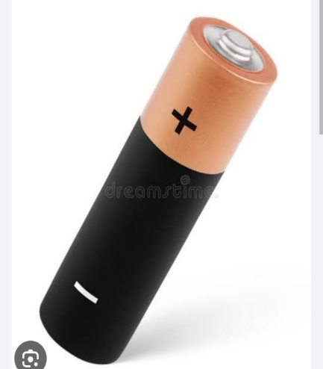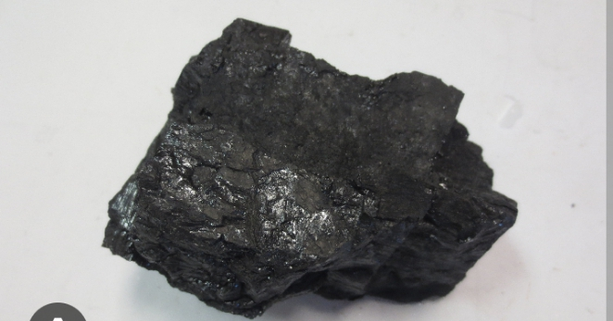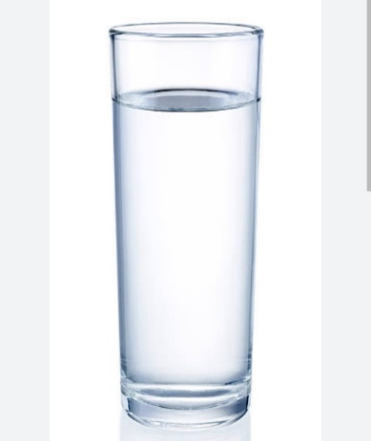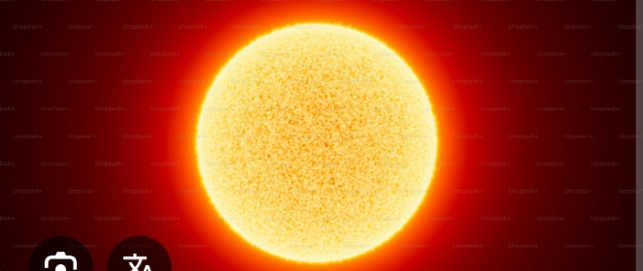

- Identify the types of energy shown in the diagram above [4marks]
(b)Define friction [2marks]
(c)State 4 uses of friction [4marks]

PART II: Answer three questions from this part
- Define the following
- Eclipse of the sun
- Eclipse of the moon
- Gravitation
- Weightlessness
- Centrifugal force
[10marks]
- (a) Explain what causes
- Day and night
- Seasons of the year [5marks]
(b) Mention five uses of planets [5marks]

- (a) Define the following
- Ovulation
- Fertilization
- Menstruation
- Menstrual hygiene [4marks]
- State three menstrual hygiene practices [3marks]
- State three symptoms of pregnancy [3marks]

- (a) A ball 20kg is lifted up a height 10meters .Calculate the gravitational force . Note g=9.8m/s [4marks]
(b) State two examples of contact force [2marks]
(c) State two examples of non-contact force [2marks]
(d) State two differences between contact force and non- contact force [2marks]

